Batch 3: Advanced Query Explanation
Q1 — LEFT JOIN + Conditional Aggregation
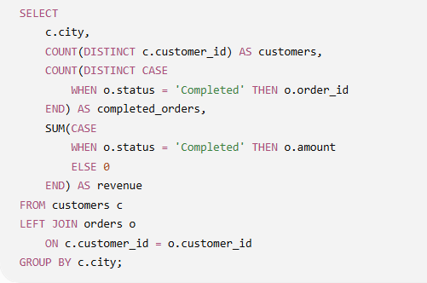
Explain the query step-by-step as an analyst:
- Why is LEFT JOIN used instead of INNER JOIN?
- What does each CASE expression accomplish?
- Why is COUNT(DISTINCT ...) used for customers and orders?
- What happens to a city where customers exist but they have no completed orders?
- What business question does this query help answer?
Answers:
- Left join is used because we want to preserve all the rows from the customer table, the final output will show all customer even if they have no placed orders.
- First case will find count of unique customers who have placed an completed order from a city, second will find the city revenue of completed orders.
- To count unique customers only.
- They still appear with null values in the output
- This is city-wise segmentation, helping us find out how different cities are performing as per revenue

Q2 — Advanced Query Explanation
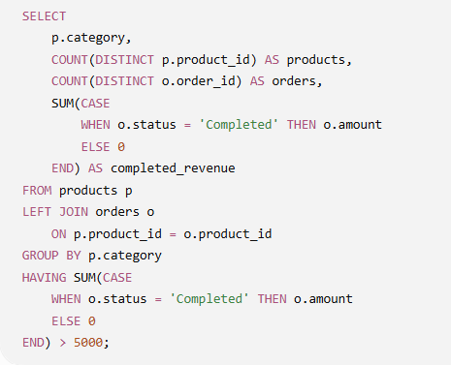
Explain this query as an analyst:
- Why is products the table on the left side of the LEFT JOIN?
- What does COUNT(DISTINCT p.product_id) tell us?
- What is the difference between orders and completed_revenue here?
- Why is the revenue condition placed in HAVING rather than WHERE?
- What business insight does the final result provide?
Answers:
- Because we want to preserve all the rows from the products table, even if a product is never ordered, it still appears with null value in the output.
- Count of unique products in a category.
- Orders are the number of orders placed, completed_revenue is the revenue generated by completed orders.
- Because groups can be filtered by having not where clause
- This is showing unique products which have completed revenue more than 5000, it tells us which products are doing well (or are above the given threshold)

Q3 — Advanced Query Explanation
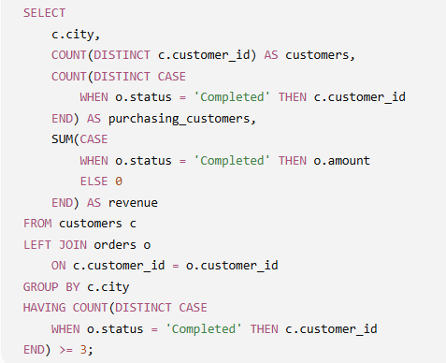
Explain:
- What is the difference between customers and purchasing_customers?
- Why is CASE applied to c.customer_id rather than o.order_id?
- Why can purchasing_customers be smaller than customers?
- Why is HAVING used here?
- What business question is this query answering?
Answers:
- Customers is the table with all the data and purchasing_customers are the customers who have placed completed orders.
- Because we want to count unique customers with completed placed orders.
- Because there might be customers with completed or no orders placed at all
- To filter out cities where al least 3 unique customers have placed a completed order
- This is city-wise segmentation, showing city performance, no. of unique customers, completed, revenue etc. To be precise, it answers, which cities have at least three unique customers who have completed purchases, and how much completed revenue do those cities generate?
Q4 — Advanced Query Explanation
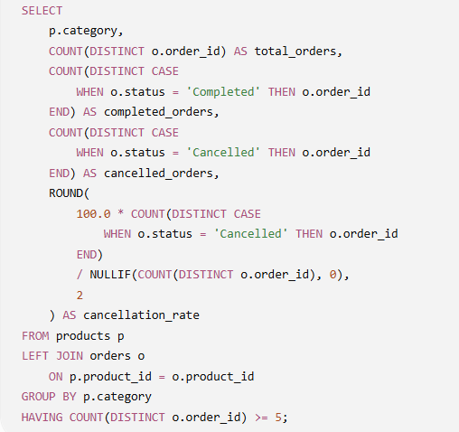
Explain:
- What does total_orders represent?
- How are completed_orders and cancelled_orders calculated?
- Explain the cancellation-rate formula in plain English.
- Why is NULLIF(..., 0) used?
- Why does the query use HAVING COUNT(DISTINCT o.order_id) >= 5?
- What business question is this query answering?
Answers:
- No. of unique orders placed per category
- Aggregation using a case and applying condition based on status
- Total number of cancelled orders divided by total no. of order multiplied by 100, gives us the cancellation rate, its basic maths for percentage calculation
- If the denominator is a 0 it will cause mathematical problems, NULLIF() is being used as a division-by-zero safeguard.
- To filter out rows where unique orders are than 4
- This is category-wise segmentation, we are finding which categories where minimum unique order are more than 4 and what percentage of those orders are being cancelled?

Q5 — Advanced Query Explanation
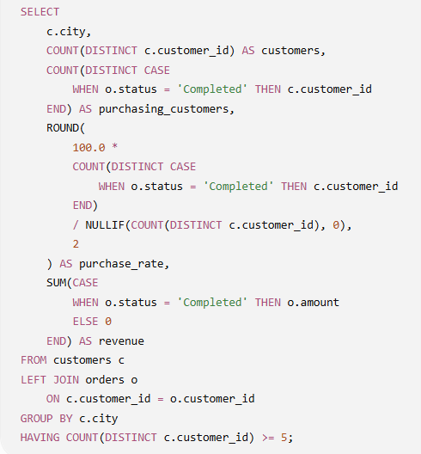
Explain:
- What does customers represent?
- What does purchasing_customers represent?
- Explain the purchase_rate formula in plain English.
- Why is NULLIF() used again?
- Why does the query use HAVING ... >= 5?
- What is the difference between purchase rate and revenue from a business perspective?
- What business question is this query ultimately answering?
Answer:
- Customers is the table that contain customers information
- It’s the count of unique customer ids who have placed a ‘completed’ order within a city
- Total completed purchases divided by total orders multiplied by 100, this is a customer conversion/penetration metric
- Nullif() is used to handle 0 in the denominator
- Its filters out cities that have at least 5 unique customers
- Segmented by city, this shows how many customers a city has, purchase rate (How effectively are we converting the city's customer base into purchasing customers?) and revenue generated by completed orders. Overall, we can say its answering, “Which cities have at least five customers, how effectively are those customers converting into purchasers, and how much completed revenue is each city generating”?
Q6 — Advanced Query Explanation
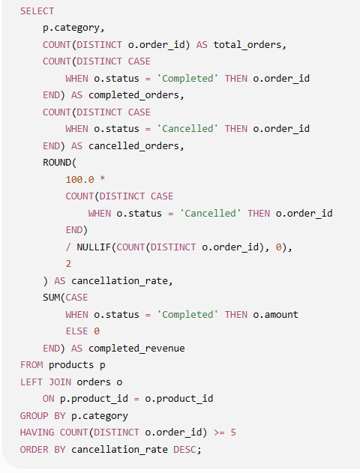
Explain this query as if you were presenting it to a business manager:
- What does the query calculate for each category?
- Why are completed_orders and cancelled_orders calculated separately?
- Explain cancellation_rate in plain English.
- Why is NULLIF() necessary?
- Why are categories with fewer than 5 orders excluded?
- What does ORDER BY cancellation_rate DESC do?
- Suppose Category A has high revenue but also the highest cancellation rate. What business concern would you raise?
- Give me the overall business insight this query is designed to provide.
Answers:
- Total orders, ‘completed’ orders, ‘cancelled’ orders, cancellations rate and revenue from completed orders per category.
- Because we have to add up the count of completed and cancelled order separately, they are 2 different metrics
- Cancelled orders divided by total order multiplied by 100 to find out the % of cancellation from total orders
- To cancel out division from 0
- Because up to 4 orders might not be business significant, though mathematically correct, they might have little effect on the overall result.
- Output is according to cancellation rate from highest to lowest, we can immediately see which categories are getting most cancellation
- We’ll try to figure out why the cancellation rates are high as high revenue suggests that this category is ‘wanted’ among customers. We should find out why so many customers are cancelling and what problems they might be facing that is leading to cancellation.
- We are basically scanning data as per category, total orders, completed revenue, completed orders, cancelled orders, with these metrics we can figure out how each category is performing and then further business actions can be taken

